CHISLET & HOATH PARISH MAGAZINE
APRIL 2021

ST MARY THE VIRGIN, CHISLET
Vicar of the Wantsum Benefice: Rev. Dr. Richard Braddy, tel: 01843 821250
Reader: Mrs. Sally Willins, tel: 01843 822428

Dear Readers,

Moving a Mobile Home

A large mobile home had to be moved on 3rd April from Reynolds Lane along North Stream and up the hill beside the Gate Inn to the grass meadows where the goats’ farm is situated. The mobile home has kindly been donated by Terry Quick to Dawn whose original home had recently been destroyed by a fire. You can imagine the difficulties which occurred in moving this rather wide home, particularly where trees were growing close to the verge, as branches had to be cut back to allow the mobile home to pass.

I had volunteered to help by controlling the traffic, by parking my car across North Stream near to the small roundabout at the bottom of Boyden Gate Hill. Luckily there was not much traffic, so the road blockage only lasted less than an hour. Church Lane also had to be blocked but only for a short while, to allow the home to turn up the Hill. Up at the farm things were a bit more complicated, owing to the contours of the farm meadows being quite steep. All the goats were tucked away safely in the barns. The mobile home was hauled using a large tractor assisted where necessary by a mechanical digger. This digger was used on the farm to remove fences, trees and to excavate and level an earth bank which then enabled the tractor to pull the mobile home up the steep incline and onto a level area covered with gravel.

All went extremely well until the mobile home was levelled into position and the framework unfortunately caught the water pipe below so that water gushed out spraying the underside of the home and the gravel bed! Luckily the water pipe was sealed up and the water stopped.

Set out in the next pages are a few of the 45 photos taken by Julia.

Rob and Julia Maxwell

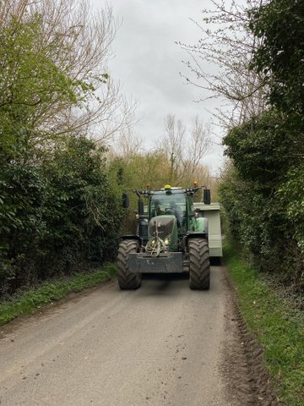

Near Reynolds Lane
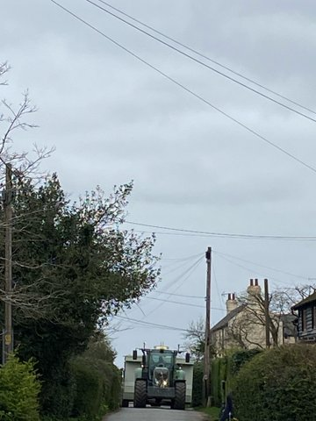
In lower Marshside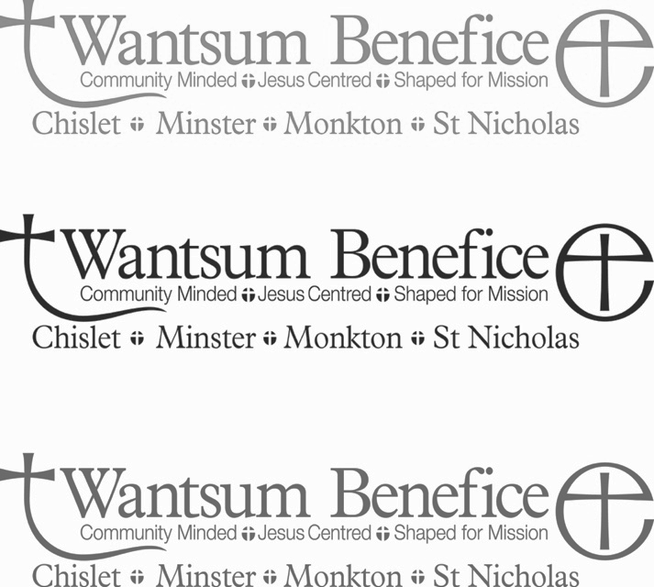
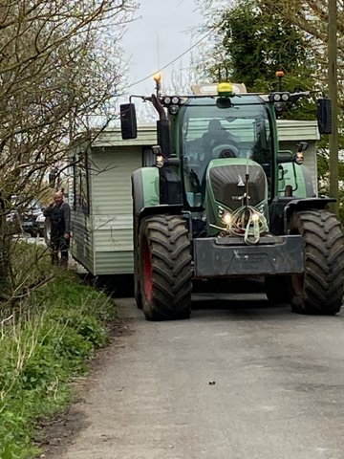

Squeezing past some branches

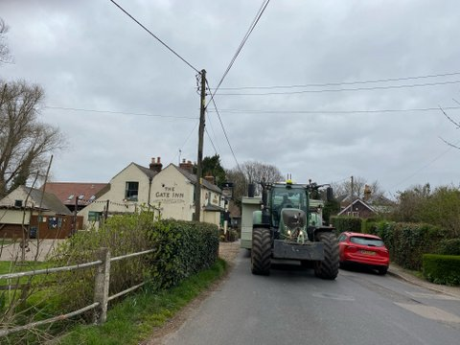Passing the Gate Inn 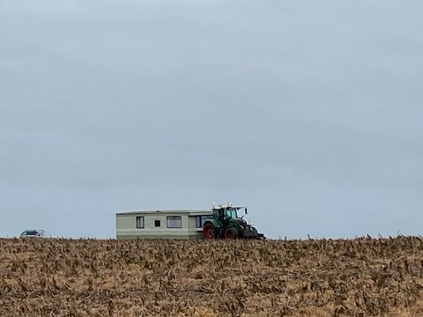

Coming up the hill to the goat farm

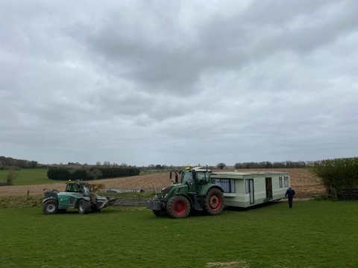

The mobile home arriving

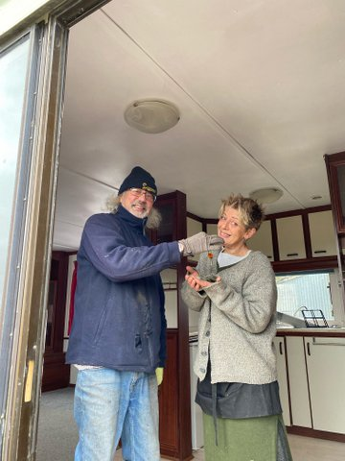

Terry (who donated the mobile home) and Dawn (the new happy owner)



We are open for prayer and worship
– join us online or in church!

Services of said Holy Communion in the Wantsum Benefice:

Sunday 11 April Sunday 18 April
9.30 Monkton 9.30 Chislet
10.30 Minster 10.30 St Nicholas

Sunday 25 April Sunday 2 May
9.30 Monkton 9.30 Chislet (non HC)
10.30 Minster 10.30 St Nicholas

Sunday 9 May Sunday 16 May
9.30 Monkton 9.30 Chislet
10.30 Minster 10.30 St Nicholas

Sunday 23 May Sunday 30 May
9.30 Monkton 9.30 Chislet (non HC)
10.30 Minster 10.30 St Nicholas

Midweek Service of said Holy Communion (BCP) held at Minster Wednesday 10.30am:
7 April 21 April 5 May 19 May

Churches open for prayer and reflection
Minster: 10.00am-4.00pm Tuesday, Thursday, Saturday and Sunday
St Nicholas: 10.00am – 4.00pm Daily
Monkton: 2.0pm-4.00pm Sunday
Church Online

Church online - informal worship on our YouTube Channel (Wantsum Benefice) – every Sunday

Daily Newsletter – with reading & reflection and links to other events –
To receive this email: info@wantsumchurches.org

Monday-Friday Morning Prayer 9.00am & Evening Prayer 5.00pm on Facebook Live
Facebook: St Mary’s Church, Minster-in-Thanet or St Nicholas at Wade Church

www.wantsumchurches.org
If you wish to talk to someone, need support or would welcome prayer please contact:
Revd Richard Braddy 01843 821250 info@wantsumchurches.org

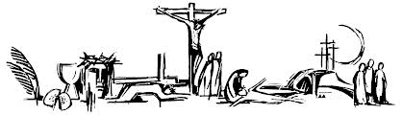

Come to church this Easter!

Come and join us as we celebrate
the Good News of the Resurrection of Jesus

We are open for prayer and worship
– join us online or in church!

Easter Day – Sunday 4 April

9.30am St Mary the Virgin Chislet
Service of said Holy Communion
Please wear a face covering (unless exempt) and maintain social distancing.

During Holy Week and Easter Week (28 March – 11 April) our Churches will be open for private prayer and reflection:

Minster Daily 10.00am-4.00pm
St Nicholas Daily 10.00am-4.00pm
Monkton Sundays 2.00pm-4.00pm

www.wantsumchurches.org
If you wish to talk to someone, need support or would welcome prayer please contact:
Revd Richard Braddy 01843 821250

info@wantsumchurches.org

********************************

Letter from Michael Darkins April 2021

We are well and truly into Spring now, a season characterised by warmth, light, life and hope. This year in particular, Spring brings with it that sense of refreshment and renewal as it heralds the gradual easing of lockdown measures. Once more this season we will be able to venture out from our homes, engaging with those people and activities we have been without for the better part of a year. This is the time of hope as we look forward to a return of normality, a world in which we do not have to live in fear every time we step outside our doors, or receive a package. We live in hope of that day soon when we can see friends for dinner, sit in a café for an afternoon, see a film, or even just shake hands with someone, or receive a hug.

But just because we have this to look forward to it does not mean that the world will look exactly as it once did. We will have each lost family, friends, livelihoods, opportunities and experiences. The streets and paths we will be able to walk with impunity will look different as the pandemic and the passage of time will have affected them. The list of those we knew prior to lockdown will be altered as people have changed in our absence and as we have developed new and unexpected relationships.

At the beginning of April the Church will celebrate Easter – the resurrection of Jesus Christ. The Gospel reading for this day is John 20:1-8 which describes Mary Magdalene’s discovery that Jesus’ burial tomb is empty and goes on to describe her encounter with the resurrected Jesus. This passage ends with perhaps one of the most simple and yet profound verses in the entire Bible, ‘I have seen the Lord’ (John 20:18). This verse does not undo everything that has happened, nor does it not deny or gloss-over the fact that Mary watched her teacher be harassed, publicly shamed, tortured and executed. Rather, it is a statement of profound truth and hope. This simple statement acknowledges the pain of the past, but signals the beginning of a future filled with untold possibilities and on that is ultimately characterized by joy and hope.

As we begin to leave lockdown behind us, and emerge from the tomb into the light of a new season, I invite you not to forget about the pain we have felt, to learn from experiences we have had, and to rejoice in the fruit that has been borne during lockdown. It is these memories and reflections which will guide us in this new season and help us make the most of it.

*********************

